Question 1: Library Management System

Scenario:
A college library currently maintains book issue and return records manually. Students often face delays while borrowing books because the librarian has to verify availability using registers.
Faculty members can reserve books in advance, while librarians can add, update, and remove
books from the catalog. Students can search books by title, author, or category. The librarian also calculates overdue fines and generates monthly reports. The college administration wants an automated system that provides faster services and minimizes manual errors. The system should also allow users to log in securely. Notifications should be sent for overdue books. Different
users should have different access rights. As a system analyst, identify the actors and their interactions.

Use Case Diagram

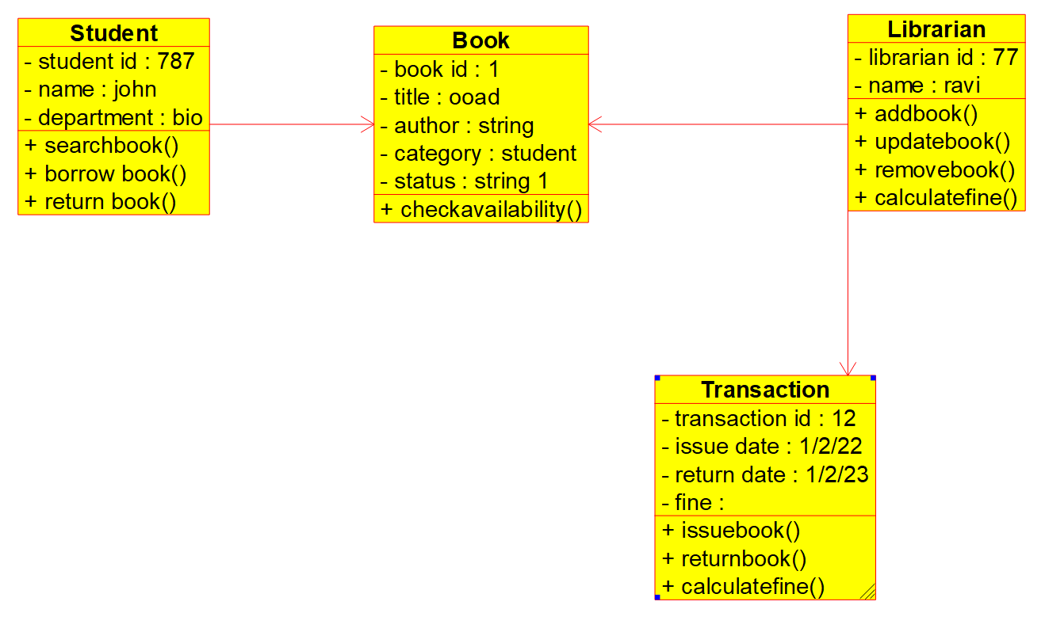
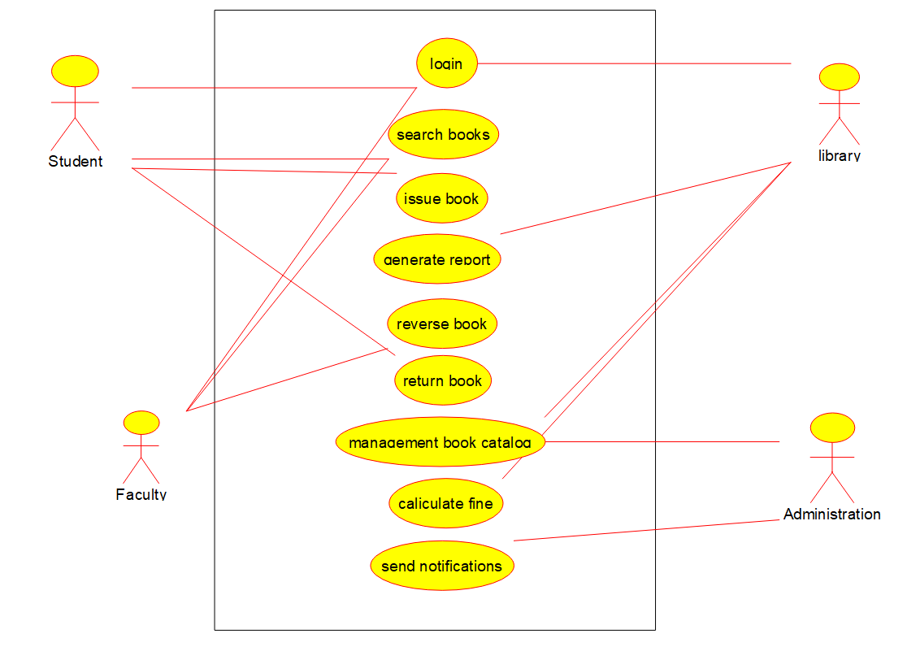
Use Class Diagram

Use Activity Diagram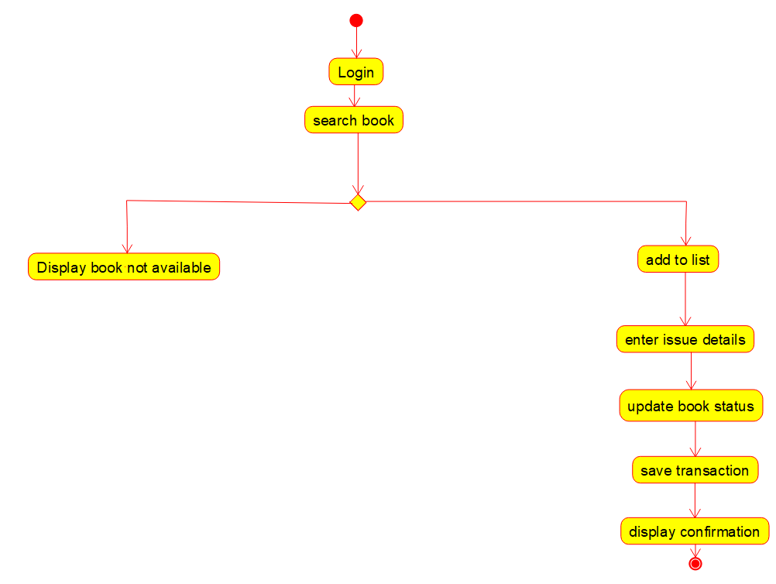

Question 2: Hospital Management System – Class Diagram

Scenario:
A multispecialty hospital wants to automate patient management. Patients can register online, schedule appointments, and access medical reports. Doctors diagnose patients and prescribe medicines. Receptionists manage appointments and billing. Pharmacists issue medicines based
on prescriptions. The billing department calculates treatment charges and insurance claims. Each patient has a unique medical history. Doctors belong to different departments. The hospital administrator manages staff information. Design the object-oriented structure for this system.

Lab Activity:
Create a Class Diagram showing classes, attributes, methods, and relationships.

Question 3: Online Shopping System – Sequence Diagram

Scenario:
An online shopping application allows customers to browse products, add items to a cart, place orders, and make online payments. After successful payment, inventory is updated automatically and an order confirmation email is sent. If payment fails, the customer is prompted to retry.
Warehouse staff process confirmed orders for shipping. Customers can track their order status.
The payment gateway validates transactions securely. Discounts are applied automatically during checkout. Customer support handles order cancellation requests. The company wants to understand the interaction between system objects during purchase.

Question 4: ATM Banking System – Activity Diagram

Scenario:
A bank plans to redesign its ATM software. Customers insert their ATM cards, enter PIN numbers, select banking services, perform transactions, and receive printed receipts. Invalid PIN attempts are limited to three. Cash is dispensed only after sufficient balance verification. Every transaction updates the database immediately. Customers can also check account balance and transfer funds. Failed transactions display appropriate error messages. Security and transaction logging are mandatory. The bank requires a workflow representation before implementation.

Lab Activity:
Draw an Activity Diagram representing ATM cash withdrawal.

Question 5: Student Course Registration System – State Diagram

Scenario:
A university provides an online course registration portal. Students first create accounts and then select available courses. Registration remains pending until fee payment is completed. Once payment is verified, registration becomes confirmed. Students may withdraw before the semester starts. Courses may become full if seat limits are reached. Administrators can reopen registration if seats become available. Students receive notifications regarding status changes. The university wants to model the lifecycle of course registration.

Lab Activity:
Construct a State Chart Diagram for course registration.

Question 6: Food Delivery Application – Communication Diagram

Scenario:
A food delivery application connects customers, restaurants, delivery partners, and payment services. Customers place food orders through the mobile application. Restaurants accept and prepare the orders. Delivery agents receive delivery requests and pick up the prepared food.
Online payment confirmation is received before delivery. Customers can track delivery in real time. Restaurants update order preparation status regularly. Delivery partners notify customers upon arrival. Customer feedback is collected after successful delivery. The company wants to visualize object communication.

Question 7: Railway Reservation System – Package Diagram

Scenario:
A railway reservation portal consists of multiple modules including passenger management, train scheduling, ticket booking, payment processing, cancellation, and reporting. Each module has independent responsibilities but communicates with others when required. Ticket booking
depends on seat availability. Payment processing communicates with external banking systems. Reporting collects information from all modules. Administrators manage train schedules and fares. The software team wants to organize system components into logical packages for better maintainability. Proper dependency management is essential.

Lab Activity:
Design a Package Diagram for the Railway Reservation System.

Question 8: Smart Parking System – Component Diagram

Scenario:
A smart parking application helps users locate available parking spaces. Sensors detect occupied and vacant slots. The mobile application displays parking availability in real time. The payment module handles online parking fees. Administrators monitor parking statistics through dashboards. The notification service alerts users before parking time expires. Security cameras monitor vehicle movement. Database servers store parking information. External payment
gateways process financial transactions. The development team wants to identify software components and interfaces.

Lab Activity:
Develop a Component Diagram for the Smart Parking System.

Question 9: E-Learning Management System – Deployment Diagram

Scenario:
A university deploys an online learning platform accessible by students and faculty members.
Students attend live classes, download study materials, submit assignments, and take online quizzes. Faculty upload lecture materials and evaluate assignments. The application server hosts business logic while the database server stores user information and academic records. Cloud
storage maintains multimedia content. Authentication servers verify user credentials. Internet access connects all users to the system. Network security protects sensitive academic information. The institution wants to visualize hardware deployment.

Question 10: Hotel Reservation System – Object Diagram

Scenario:
A hotel reservation application manages customers, rooms, reservations, payments, and staff. Customers search available rooms based on dates and room categories. Receptionists confirm bookings after payment verification. Housekeeping updates room availability after cleaning.
Managers monitor occupancy reports and revenue statistics. Customers receive booking confirmation messages instantly. Rooms can be reserved, occupied, or under maintenance. Staff information is maintained separately. The management wants to view the runtime instances of objects involved in a booking.

Lab Activity:
Construct an Object Diagram representing a hotel room reservation scenario.

These scenario-based questions cover the major UML diagrams commonly practiced in an Object-Oriented Analysis and Design (OOAD) Lab:

- Use Case Diagram
- Class Diagram
- Sequence Diagram
- Activity Diagram
- State Chart Diagram
- Communication Diagram
- Package Diagram
- Component Diagram
- Deployment Diagram
- Object Diagram

